Y orkie Yapper
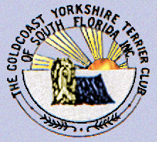
Goldcoast Yorkshire Terrier Club
Of South Florida Inc.
Sherill Freeman, Editor; 5750 SW 48th St. Davie, FL. 33314  Cell 954-850-2309 email:sherillfreeman1@bellsouth.net     | October 2021  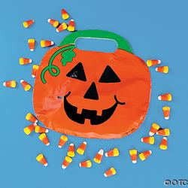

Happy Halloween to All!

Next Meeting: Bonefish Grill 9598 Glades Rd. Boca Raton, Fl. 33434 on 10/30 at 1 pm. 561.483.4949 Pike to Glades and go west. Please rsvp to Betty Gansky. I have a raffle planned.

PROGRAM: Club business will be discussed.

Happy Birthday to:
☺
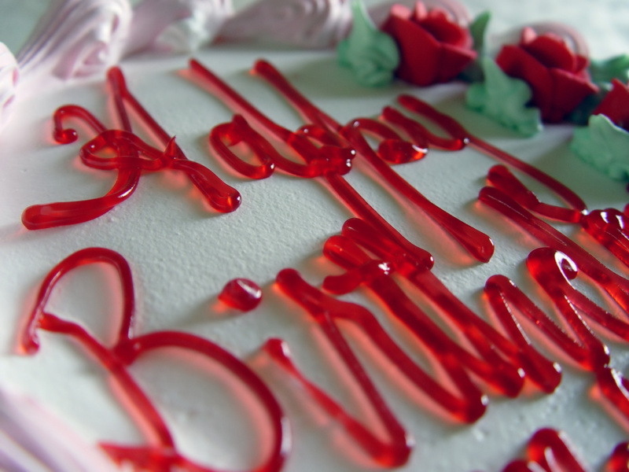

Betty Gansky 10/9 Pat Cupp 10/17 & Leslie Stolfi 10/20

W
Check out our website @ www.goldcoastyorkieclub.org

Looking for suggestions for the holiday party. Please give me your inputs at the meeting.

Some days you are the dog. Some days you are the hydrant.

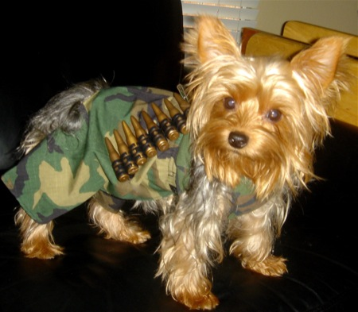

Happy Halloween!

BRAGS

This plaque was earned in 2019. I received that at the Goldcoast Yorkshire Terrier Club luncheon this April 2021. We didn't have an Award luncheon in 2020. Fate earned 8 titles in 2019 at the age of 2!!! Her CD & CDX in Obedience, her RA & RE in Rally & 4 in Agility at only 2 years of age!

Then the pandemic hit in 2020! No shows until near the end of '20.
I'm proud to say that Fate earned her UD title today on 6/12/21 at the Obedience Training Club of Palm Beach County's trial in Lake Park I’m so very proud of my little girl!

Betty & the "Working Yorkies"

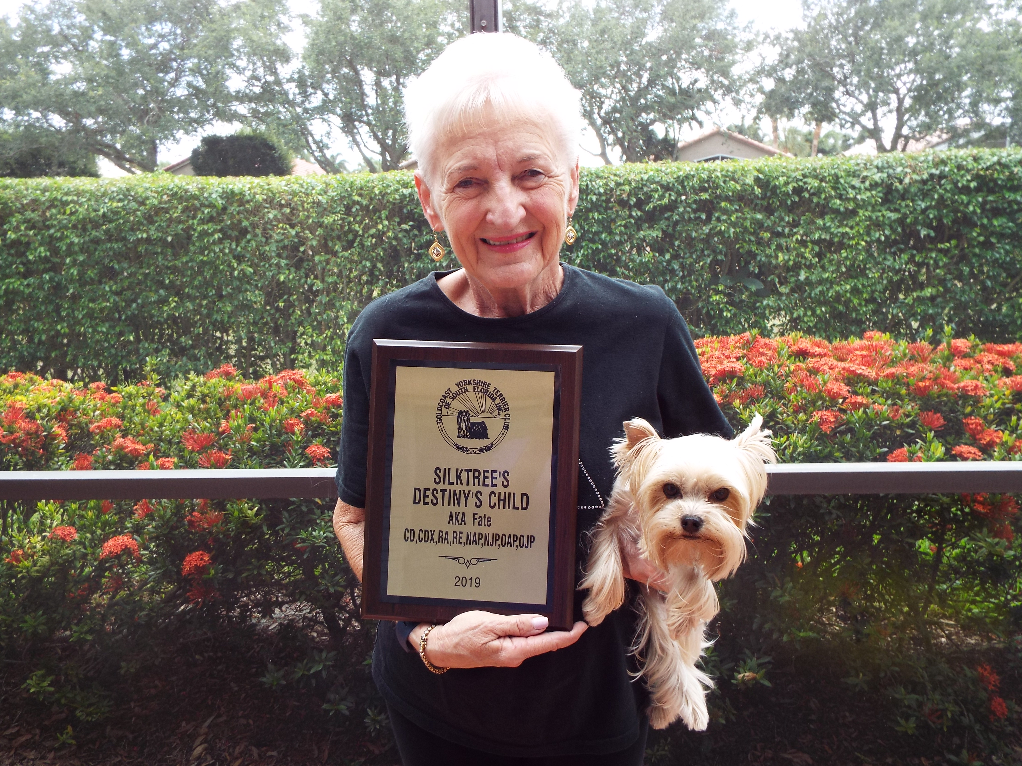

Sorry members. I’ve had computer problems and did not get Betty’s brags. So here we go with catch up.
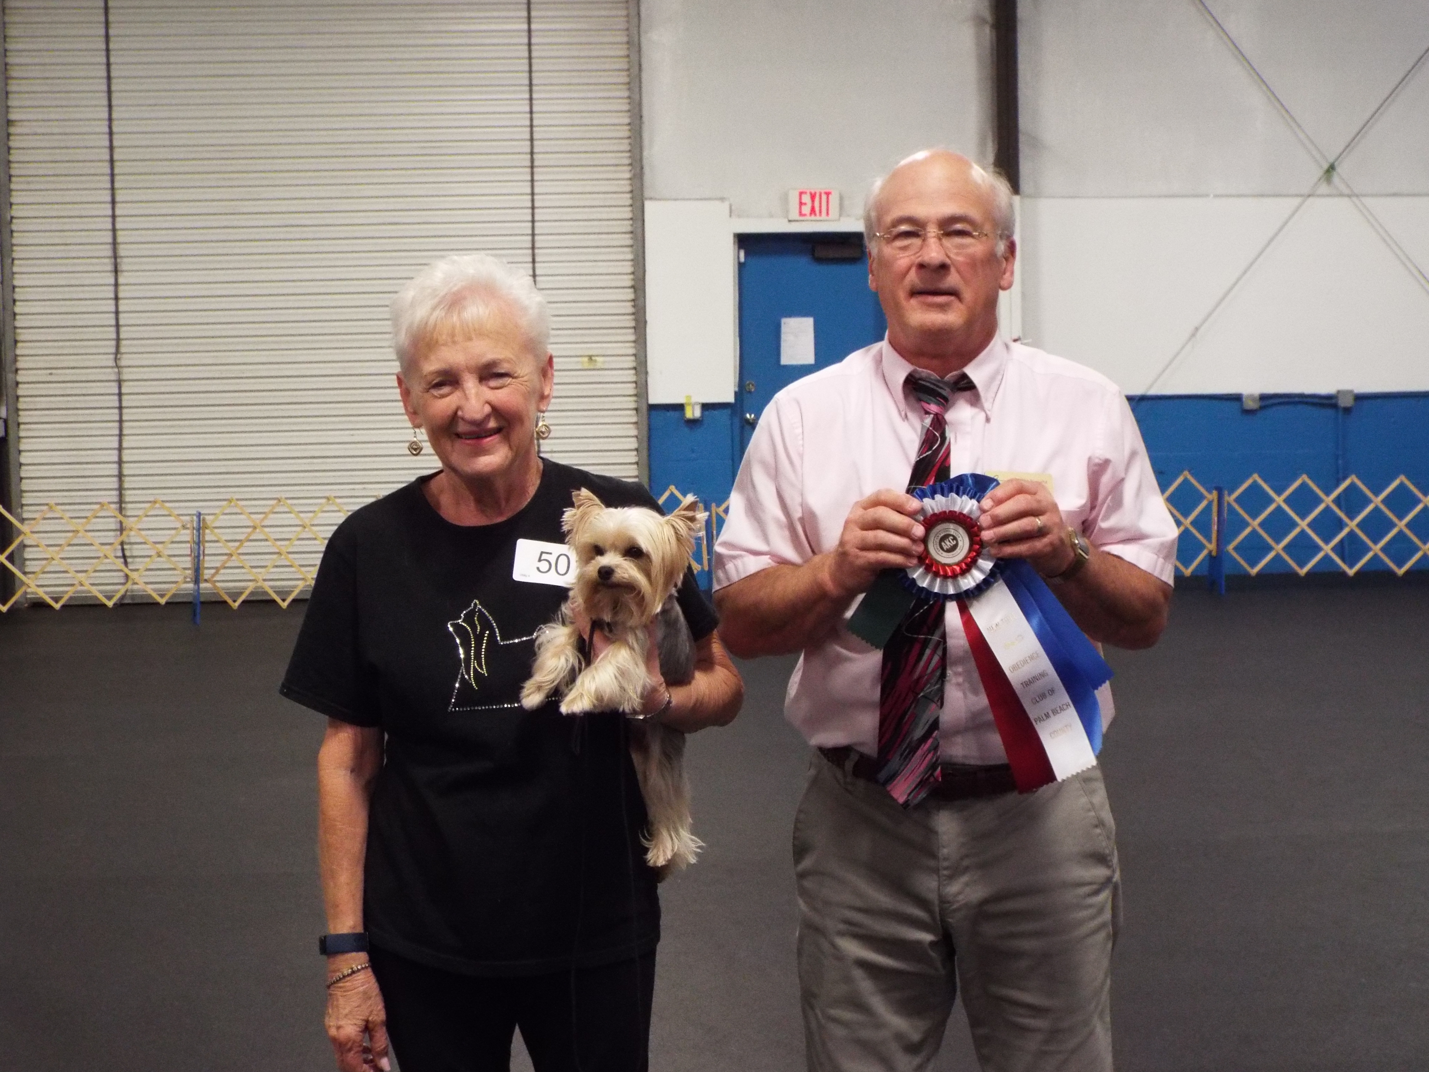

Well Fate had a VERY good day today 7/25/21. Unfortunately, her handler was not up to top par! In the AM classes in Excellent I did a sign wrong & lost 10 points ending with a score of 90 which would have been 100! In Advanced we earned 100 & 1st place. She was the only dog in the class to earn 100!

In the afternoon in Excellent I made a small error that cost us another 10 points thus ending with a 90 instead of 100.

When I went in the Advanced class this afternoon, I told the judge that Fate was going to advertise in the classifieds tomorrow for a NEW handler! He laughed! We then completed the course with another perfect score of 100. BTW there were 3 dogs that had a perfect score in the that class. When that happens, the shortest time taken wins first place & so on. The Standard Poodle that has a Champion Rally title came in 3rd, the Flat-Coated Retrieve came in 2nd & Fate came in first beating the 2nd place dog by 20 seconds!!!

If not for MY two errors, we would have won High Combined at both trials today! Oh well! I'm still thrilled! She now has 8 RAE legs with only 2 more to go! Unfortunately, there are no more local Rally trials until November!

Attached is her 1st place win other the other two big dogs. The other two are her 1st place wins today in Advanced.

Submitted by Betty Gansky

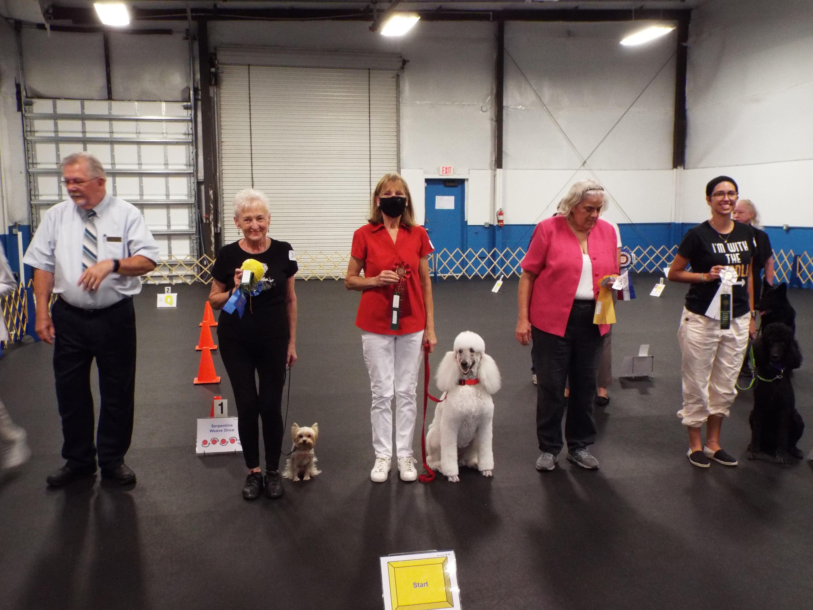

10/2/21 Fate & I had an outstanding win at the MOC Obedience trials held at our clubhouse. Fate earned her very 1st UDX leg on her very 1st attempt at this title.

She was amazing, earning a 194 1/2 in Open (this is right after she was attacked but thankfully not injured by a Standard Poodle the last dog in Novice A) who ran out of the ring.

Fate was the 1st dog in Open. She was nervous going in but did a terrific job earning 3rd place & a 194 1/2. She later went into Utility & earned a 192 1/2 & 2nd place. The Q rate at the trial was very low.

The BEST news is that she won High Combined! She is the very 1st Yorkie I've owned to earn a High Combined award at an All-Breed show!

Betty & the "Working Yorkies".

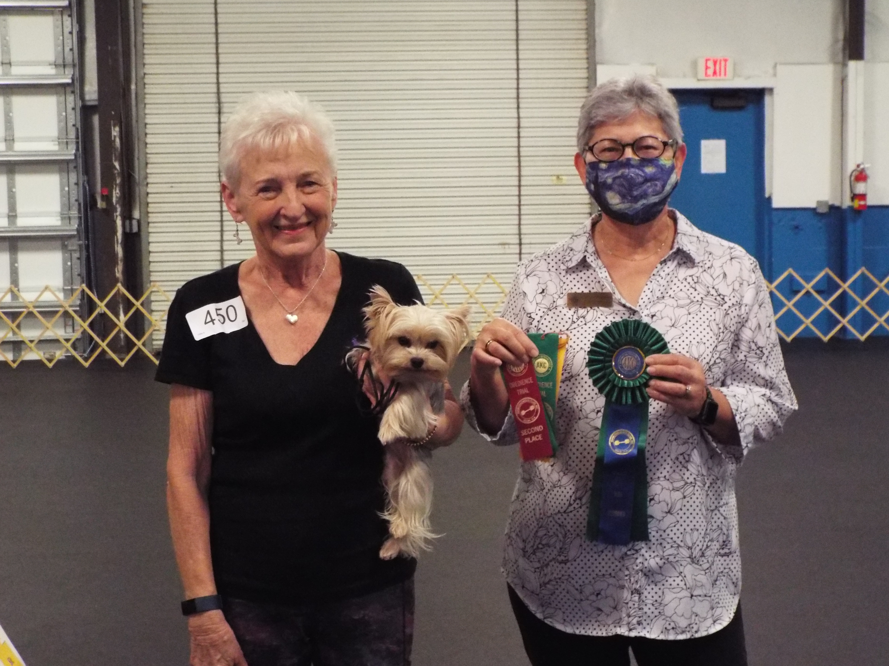

Fate showing them how it’s done.
Congratulations Betty and Fate!

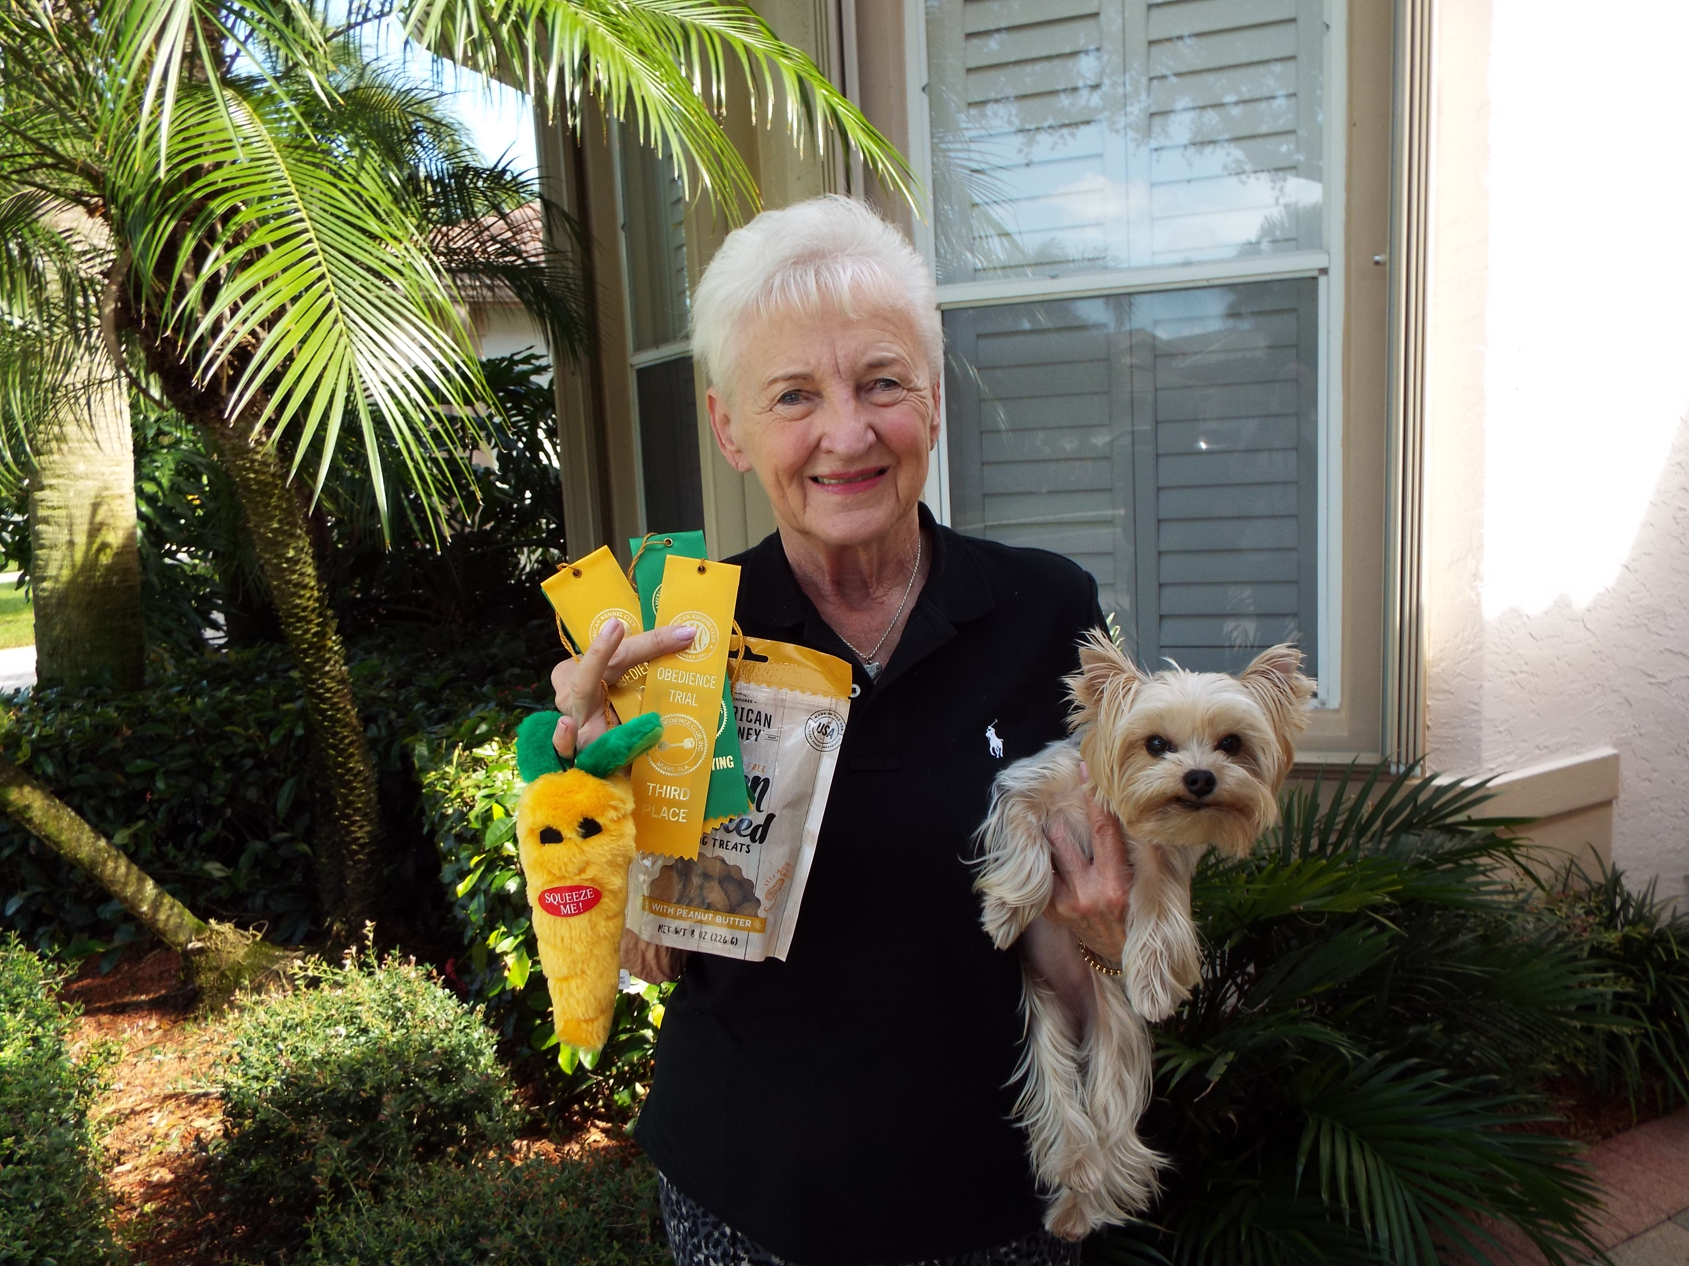

We earned our 2nd UDX leg today (10/3/21) at the MOC trial held at our clubhouse.

Fate took 3rd place in both Open B with a score of 195 1/2 & in Utility B with a 194 1/2. This was her 2nd consecutive UDX leg. Two down & 8 to go!

What a GREAT little dog she is!

Betty & the "Working Yorkies"

