/i
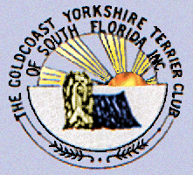 Y orkie Yapper
Goldcoast Yorkshire Terrier Club
Of South Florida Inc.
Editor; Sherill Freeman, 5750 SW 48th St. Davie, FL. 33314  954-850-2309 cell email: sherillfreeman1@bellsouth.net  Happy St Patrick’s Day! | 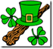  March 2020
NEXT MEETING: June 20th (Saturday), Annual Awards luncheon

PLACE: TBD and posted next month.

Directions Please RSVP to Sherill so she can arrange seating by 6/1/20 @ sherillfreeman1@bellsouth.net or cell 954 850 2309.

PROGRAM: Club business will be discussed then the awards.

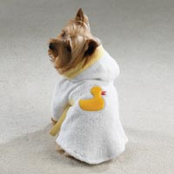
Greyhounds are universal blood donors. Most greyhounds have a blood type that can be given to almost any other breed of dog on the planet.



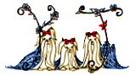

Check out our website @ www.goldcoastyorkieclub.org

The best vitamin for making friends....B1.

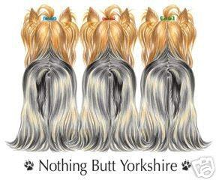

Annual Awards

The Goldcoast Yorkshire Terrier Club of South Florida will be presenting awards at the
annual banquet. Yorkshire Terriers that qualified between January 1st and December 31st, 2019 can only be submitted. To qualify for any awards, applications must be received by
May 1st, 2020 by mail (sherillfreeman1@bellsouth.net) to Mrs. Sherill Freeman at the address listed below.
AWARDS:

1. A.K.C. Champion
2. A.K.C. Obedience Title
3. Top Sire (Minimum of 2 Champions from this sire to qualify)
4. Top Dam (Minimum of 2 Champions from this dam to qualify)
5. Top Breeder (Minimum of 2 Champions of your breeding)
6. A.K.C. Best In Show or Specialty (First Only)
7. Rally Awards

If you are applying for any of the awards (with the exception of the service award), type or print the appropriate information on this form and mail to:

Sherill Freeman
5750 SW 48th St.
Davie, FL 33314

AWARD CATEGORY NAME_________________________________________________________

REGISTERED NAME OF DOG__________________________________________________________

A.K.C. NUMBER___________________________________________________
BREEDER NAME(s) ________________________________________________

OWNER NAME(s) __________________________________________________

LIST ALL PROGENY (FOR TOP SIRE, DAM, OR BREEDER AWARDS ONLY)
_____________________________________________________________
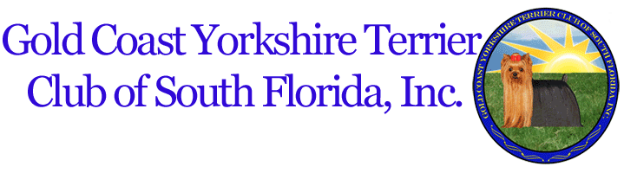

We value you as a member, Membership dues are $20.00 per year for each
single membership, $25.00 per year for a dual membership (husband and wife), and payable to: GYTC please continue your membership by sending your dues by June 1, 2020 to:
-------------------------------------------------------------------------------------- Pat Cupp
6095 Bay Isles Drive
Boynton Beach, Fla. 33437

Name(s) __________________________________________

Address__________________________________________

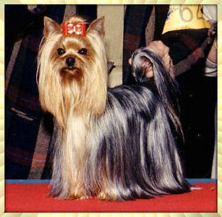
Upcoming Specialty

Our Show will be held on 7-11-2020 in WPB.
All trophies placements have been sponsored! “Thank you”

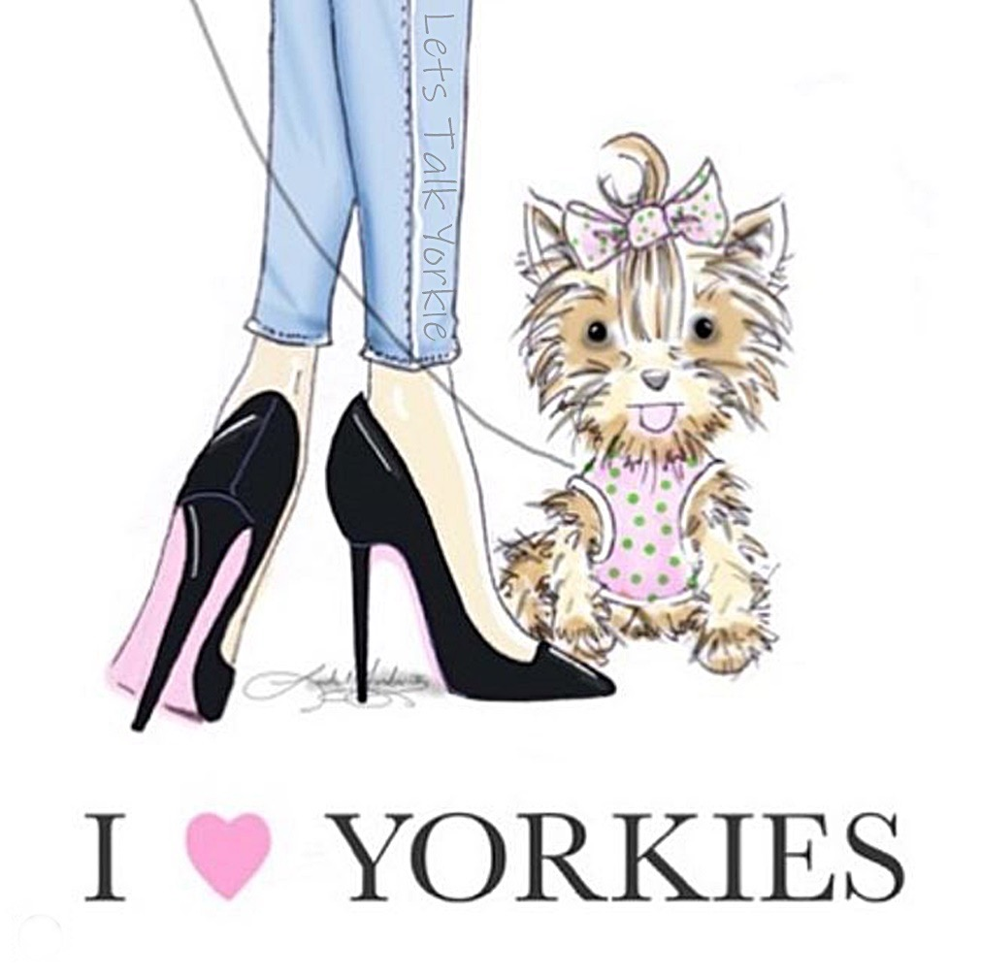
Brags
Charlie and Andy (litter brothers) were shown at the Fort Lauderdale Dog Club shows on February 22 and 23, 2020 in Davie. Charlie (on the left) got Winners Dog both days and Andy got Reserve. Charlie lives with Carole Della Penna and Andy is with Leslie Stolfi.

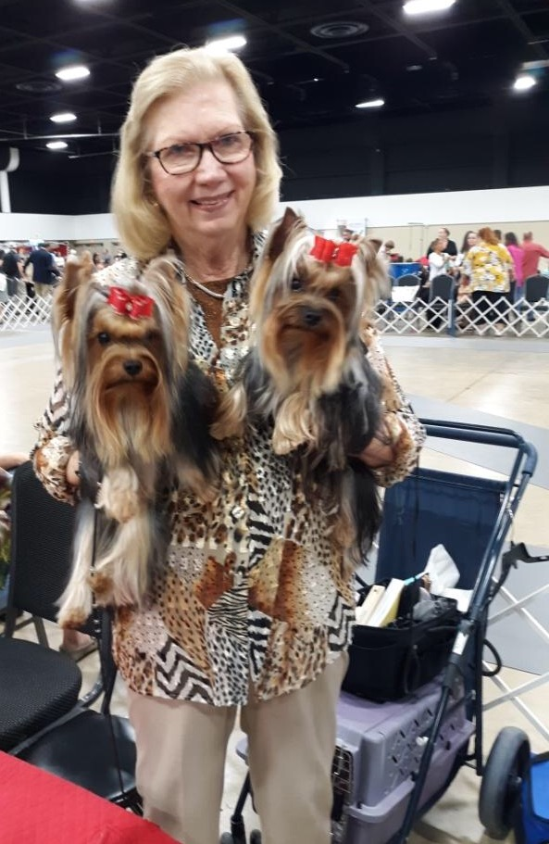
New AKC Champion

Ch. Majestics Masterpiece of Lilykin

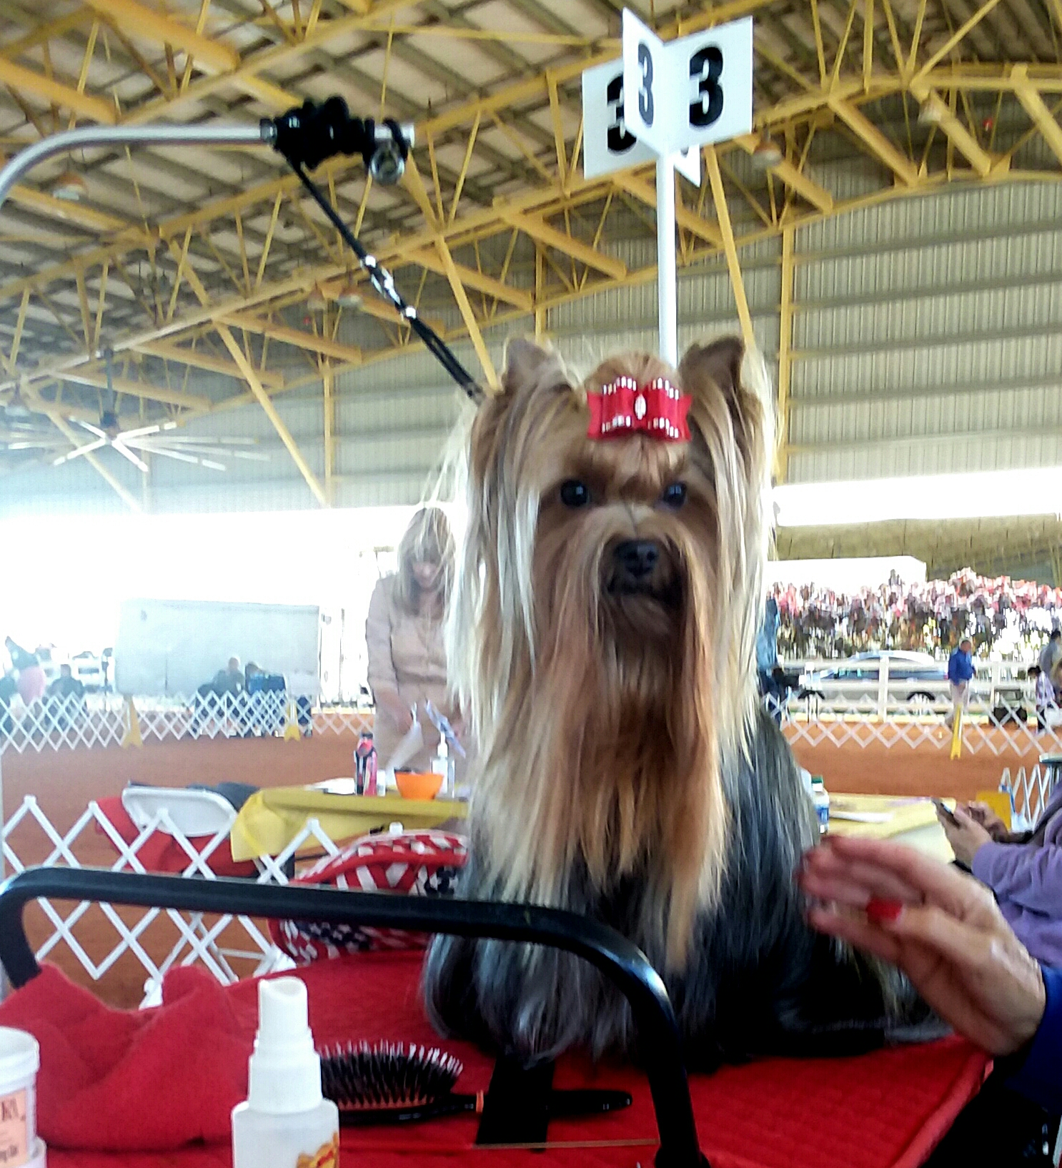

George qualified for his Grand Championship on January 16, 2020 George...Ch Majestics Masterpiece of Lilykin is co-owned and co bred by Carole DellaPenna and Leslie Stolfi.

