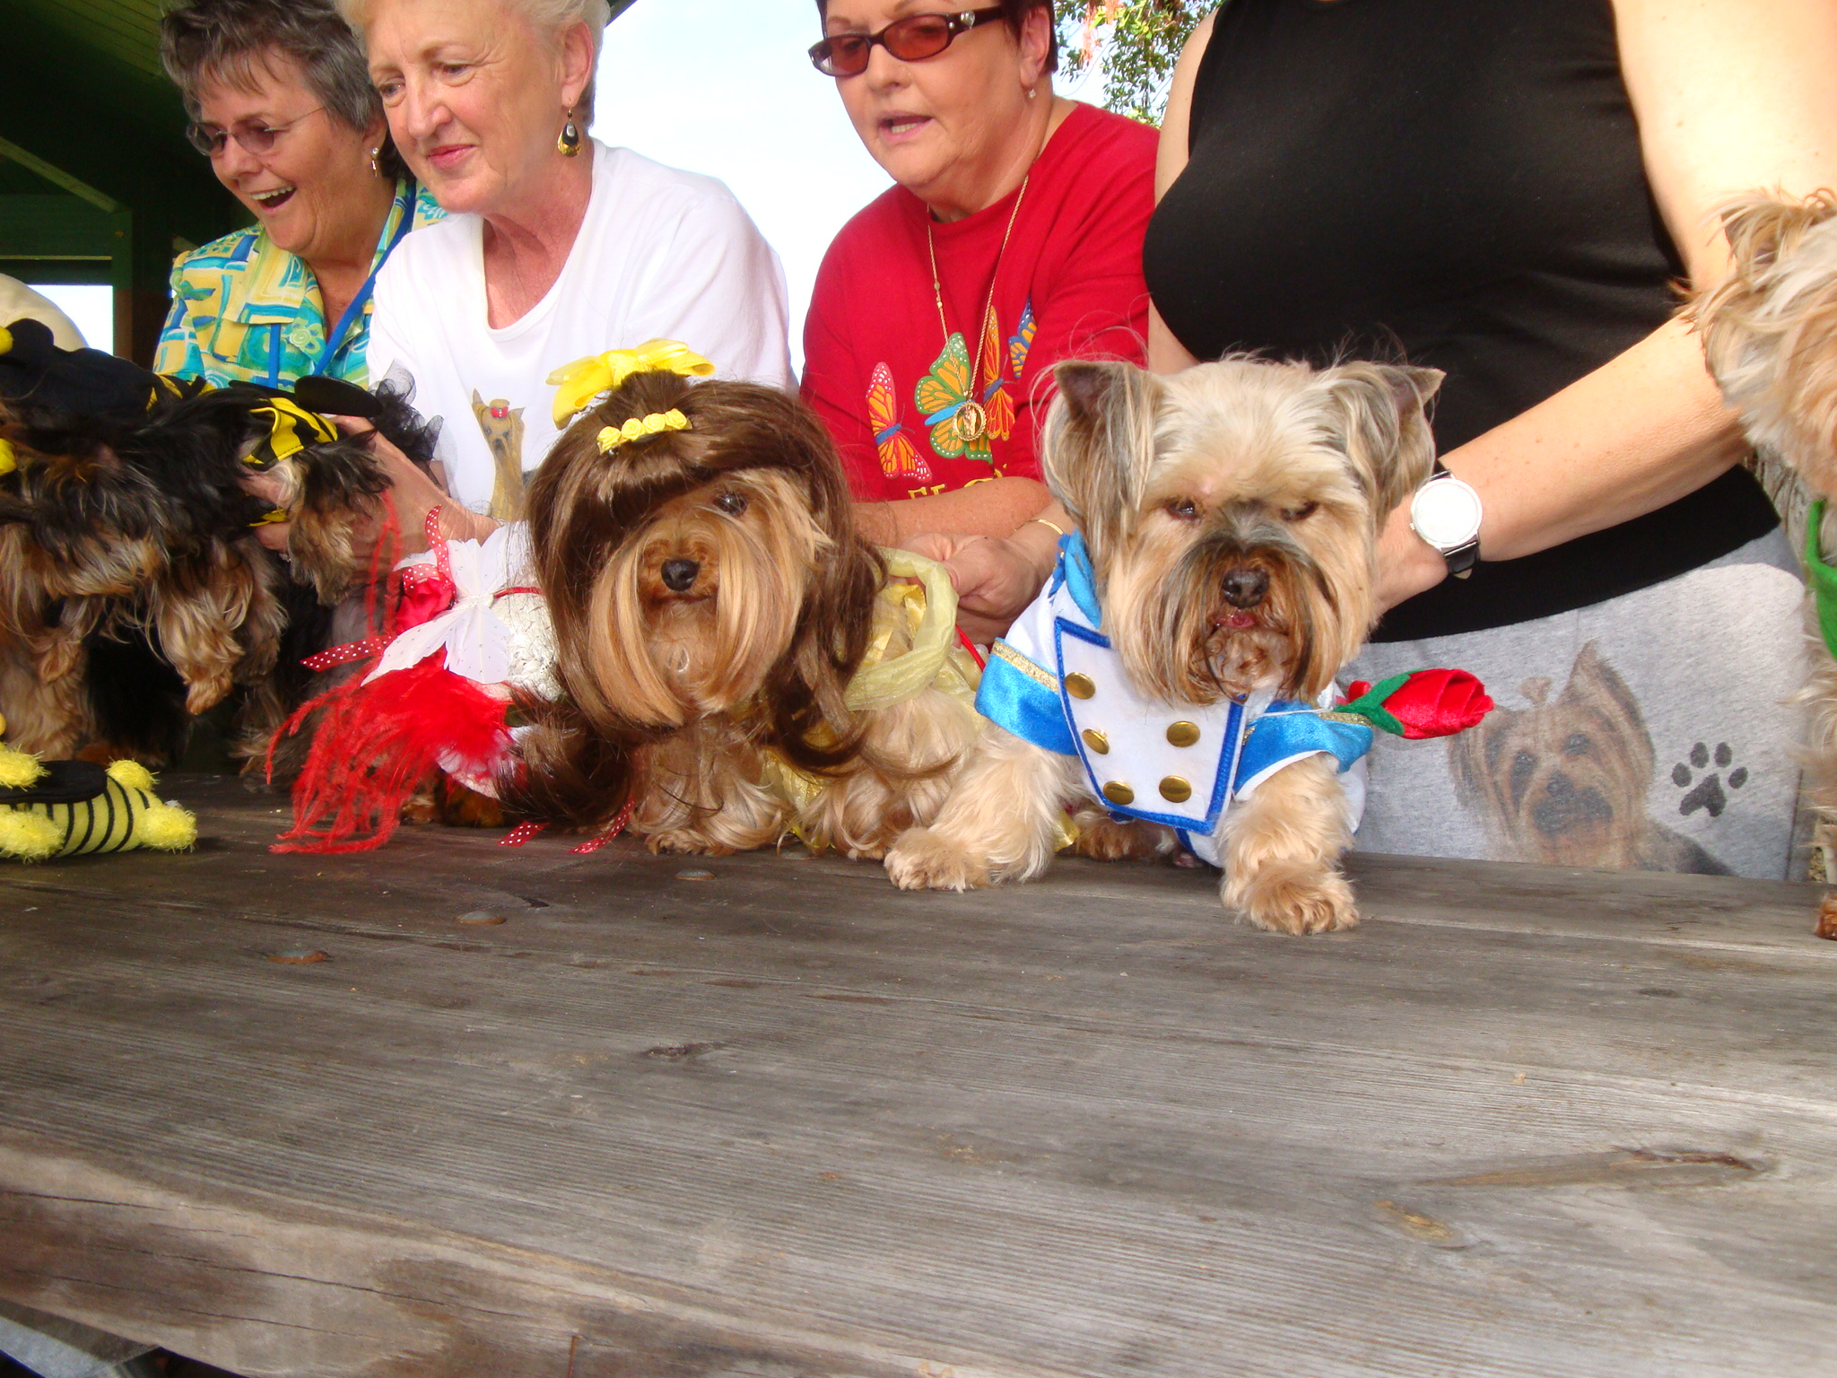

Y orkie Yapper
Goldcoast Yorkshire Terrier Club Of South Florida Inc.

Editor; Sherill Freeman, 5750 SW 48th St. Davie, FL. 33314 954-850-2309 email:sherillfreeman1@bellsouth.net  Next Meeting: Holiday Luncheon. 12/14/19 Jeff & Betty’s home.  @1 p.m. The cost will be $20.00 per person. Checks can be sent to Pat Cupp @ 6095 Bay Isles Drive Boynton Beach, FL 33437.  Please RSVP to Betty Gansky by 12/07/19. Payment must be sent to Pat Cupp by 12/7/19.  Reminder-Please bring a wrapped gift worth at least $20 for the Chinese gift exchange. | December 2019  "There is always, always, always  something to be thankful for."  -Author Unknown  "The greatest mistake you can  make in life is to continually  be afraid you will make one."



Thanksgiving didn't become a national holiday until over 200 years later! Sarah Josepha Hale, the woman who actually wrote the classic song “Mary Had a Little Lamb,” convinced President Lincoln in 1863 to make Thanksgiving a national holiday, after writing letters for 17 years campaigning for this to happen.

 Happy Birthday to Mikie Davis (silver member) 12/26.
We are all sending you a hug from Florida. We miss you!

Please RSVP to Betty Gansky by 12/7/19 if you can attend.

We will be doing our famous Chinese gift exchange.

Please bring a wrapped gift worth at least $20.

We will be ordering from Mama Mia’s. We will offer these choices: Chicken Parm~Eggplant Mama Mia~Ziti w/3 cheeses~Lasagna with meat for $20 per person. Also, gluten free pasta is available for $2 extra. These dishes will include salad, garlic rolls and dessert. Bring your own drink please.
We will have our normal Chinese raffle. So please bring a wrapped gift valued at $20 minimum if you want to participate.
Everyone must rsvp to Betty and pay by 12/7. Please send a check made out to GYTC to Pat Cupp, 6095 Bay Isles Drive, Boynton Beach, FL 33437

Directions to Betty & Jeff Gansky's

From I-95: Go North to Woolbright Rd. turn W. (left). Follow Woolbright to Jog Rd turn left (South) to the 1st light which is Grand Isles. Make a right turn on Grand Isles. It is the entrance to Valencia Isles where I live. Come thru the guard gate & make a left at the lake. Stay to the left & make a left on the very 1st street which is Malta. After turning left on Malta make the very 1st right (immediate) onto Lanai. Follow Lanai to the end & make a left onto Bali Hai Drive. My address is 6634 Bali Hai Drive. I'm ¾ of the way down the street on the right side.

From the Turnpike: Get off at the Boynton Beach Blvd exit & go East to Jog Rd. Take Jog Rd to Grand Isles & turn right.

Follow the directions above after entering Valencia Isles.

From Jog Rd: Valencia Isles is one light S. of Woolbright Rd. Turn into Valencia Isles & follow directions above.

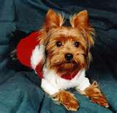

Hope to see you there!

Brags

Fate earned her Rally Excellent title the weekend of November 16th & 17th in 3 shows.

Our 1st show was Saturday afternoon & we qualified with a score of 94 due to ME
getting lost on the course.

On Sunday she was perfection! She earned 1st place in the morning with a perfect score of 100. On Sunday afternoon she earned another perfect score of 100 but due to time she placed 2nd. The judge was SO impressed! The shortest time was with a Lab whose time was 1:46:44 seconds. Fate's time was 1:46:88 seconds. Considering the size difference
it was amazing!

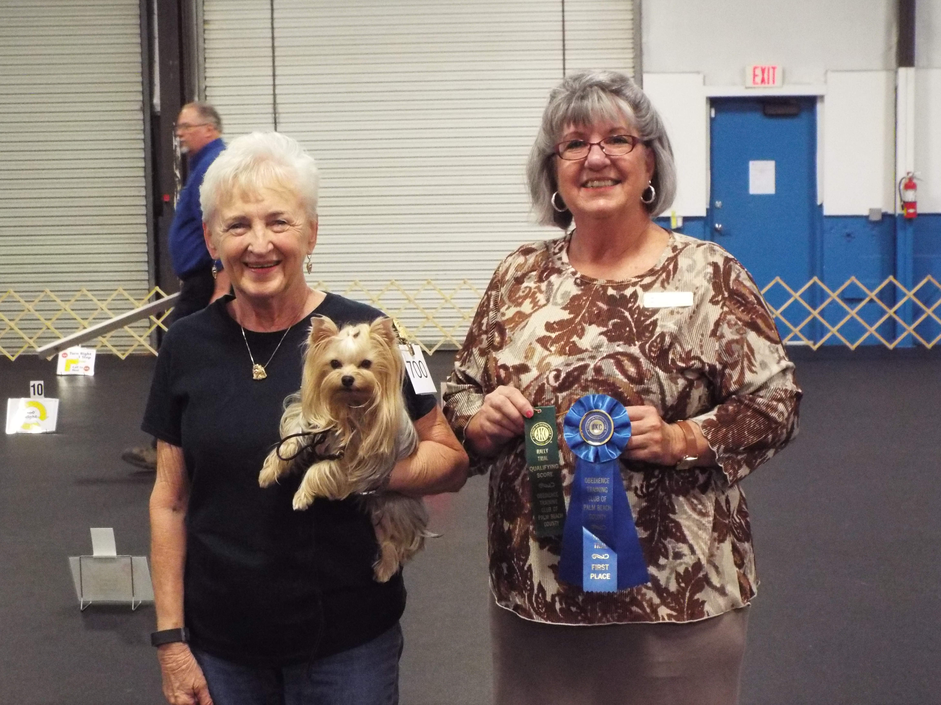
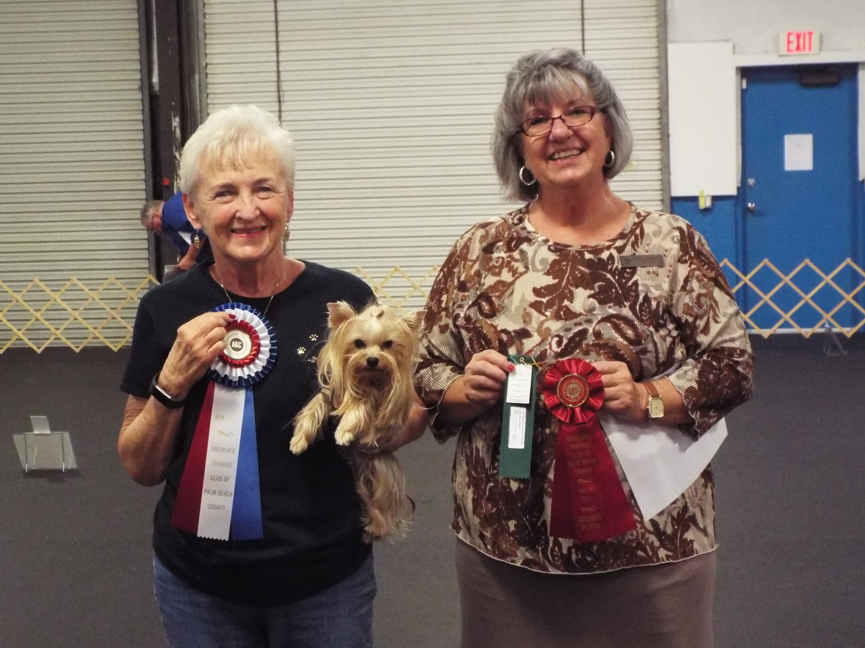

Congratulations to all!

Andy (on the right) was winners’ dog at the Toy Dog Club show on July 11th in West Palm Beach. This was his first win, he got two points. His litter brother (Charlie) is on the left. Submitted by Leslie.



