/i
 Y orkie Yapper
Goldcoast Yorkshire Terrier Club
Of South Florida Inc.
Editor; Sherill Freeman, 5750 SW 48th St. Davie, FL. 33314  954-850-2309 cell email:sherillfreeman1@bellsouth.net  Happy Father’s Day! |  June 2019

Annual Awards Luncheon: 6/22/19 (Saturday)
@ Sawa Hibachi Steakhouse 1 p.m. Cash only. “Raffle”

"Sawa Hibachi" restaurant located in the "Shoppes at Woolbright" 10817 Jog Rd, Suite 210, Boynton Beach, FL 33437.The price is $23.00 including full meal, tax, tip. Please RSVP to Sherill ASAP. Choice of Chicken, Shrimp, or Steak Hibachi & will include, soup AND salad, white rice, noodles & vegetable. No drink included this year.

Upcoming Dog Shows: See www.akc.org and/or www.Infodog.com

Check out our website @ www.goldcoastyorkieclub.org

Did you know that when you help someone, the help is returned in two-fold?
Reminder: Yorkie Specialty 7/13/2019

I will alert everyone with the time and ring number as soon as I know.

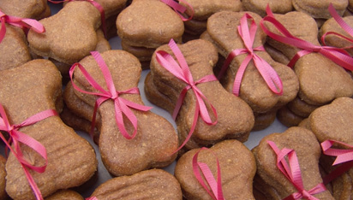

Thought for Today -
No matter how hard things are,
Tomorrow's a fresh opportunity to make things better.
Here's your (not so) totally useless fact of the day:
Costco sells over 100 million hot dogs annually; more than every MLB stadium
combined.
A special Birthday Wish goes to:
Carol Yerkes 6/17

BRAGS

I'd like to wish Buttons a VERY happy 13th birthday May 26th! He has been a wonderful
little dog!

The picture here was taken when he was about 5 years old in celebration of July 4th.

Buttons completed over 660 Pet Therapy visits from the age of 2 until 10 when he retired.
He also earned his Nat'l International, UCH in breed, CDX in Obedience, RE in Rally, TKA in Tricks as well as numerous Agility titles.

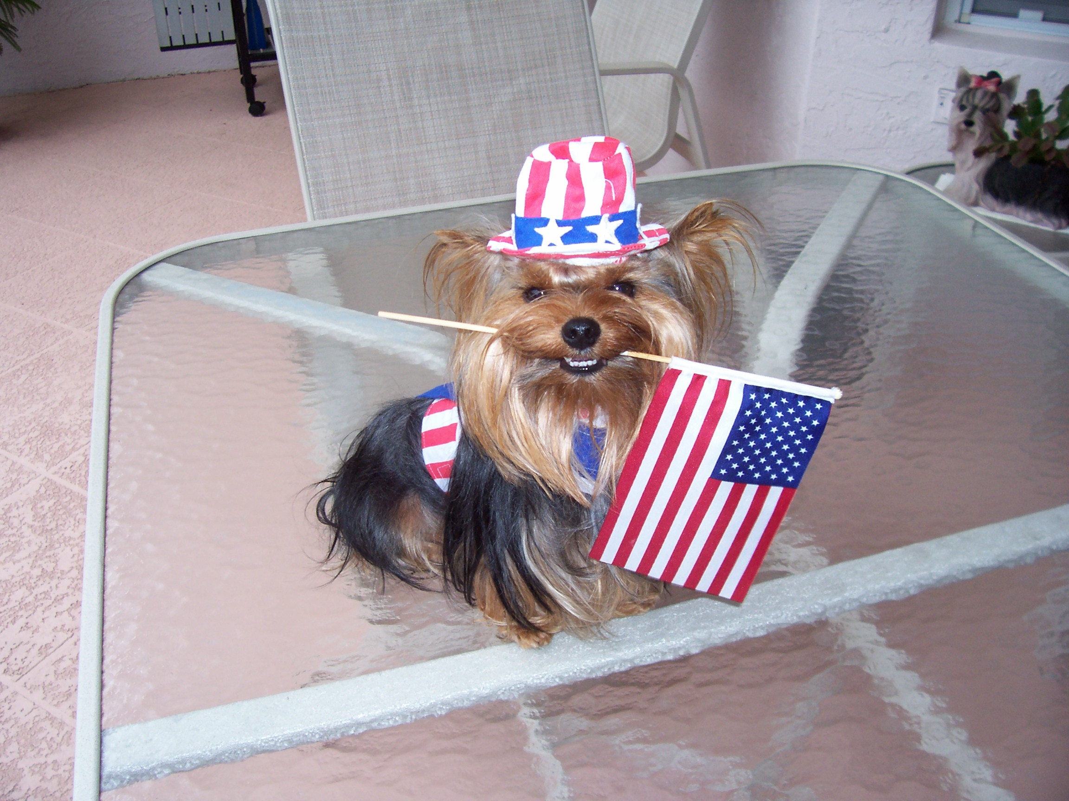

Submitted by Betty Gansky
I'm happy to report that Fate earned her 1st leg in Open A with a first place on 5/25/19 with a score of 192. It was her 1st time in Open.

This picture isn't the greatest as MY photographer was not there! She was 21 months old on May 27th.

Sunday 5/26/19 we weren't that fortunate! When doing the signal discrimination which she normally does perfectly she belched as I gave her the down signal! That's the last time she will have a piece of dehydrated hot dog before entering the ring! LOL!



