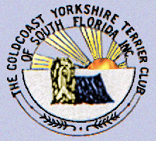 Y orkie Yapper
Goldcoast Yorkshire Terrier Club
Of South Florida Inc.
Sherill Freeman, Editor; 5750 SW 48th St. Davie, FL. 33314  954-850-2309 email:sherillfreeman1@bellsouth.net    Happy Mother’s Day!   | 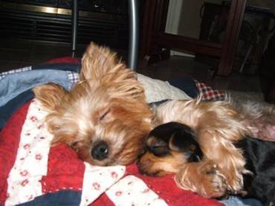  May 2019

Annual Awards Luncheon: 6/22/19 (Saturday)
@ Sawa Hibachi Steakhouse 1 p.m.

"Sawa Hibachi" restaurant located in the "Shoppes at Woolbright" 10817 Jog Rd, Suite 210, Boynton Beach, FL 33437.The price is $21.00 including full meal, tax, tip & beverage. The hibachi lunch will consist of: Shrimp, Chicken or Steak, white, fried or brown rice, soup & salad.

PROGRAM: Club business will be discussed.

Get ready for our Specialty Show 7-13-2019

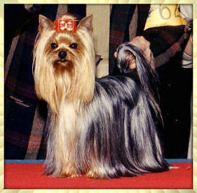

Happy Birthday to:



Patsy Freeman 5/1
Jackie Ledea 5/1
Linda Bryer 5/12
Shelley Dylla 5/18
Kelly Smith 5/23

W

---------------------------------------
DUES

We value you as a member, Membership dues are $20.00 per year for each single membership, $25.00 per year for a dual membership (husband and wife) payable to: Goldcoast Yorkshire Terrier Club of South Florida, Inc Please continue your membership by sending your dues by June 1, 2019 to:

Ms. Pat Cupp
6095 Bay Isles Drive
Boynton Beach, FL 33437
Name(s) __________________________________________

Address__________________________________________

Type of Membership_________SINGLE______________DUAL

AMOUNT ENCLOSED $_________________________________
What Makes Chocolate Toxic to Dogs
GOLDCOAST YORKSHIRE TERRIER CLUB OF SOUTH FLORIDA, INC.

AWARDS DINNER DATE 6/22/19

The Goldcoast Yorkshire Terrier Club of South Florida will be presenting awards at the annual banquet. Yorkshire Terriers that qualified between January 1st and December 31st, 2018 can only be submitted. To qualify for any awards, applications must be received by May 1st, 2019, by mail, email, (sherillfreeman1@bellsouth.net.) to Mrs. Sherill Freeman at the address listed below.
AWARDS:
1. A.K.C. Champion
2. A.K.C. Obedience Title
3. Top Sire (Minimum of 2 Champions from this sire to qualify)
4. Top Dam (Minimum of 2 Champions from this dam to qualify)
5. Top Breeder (Minimum of 2 Champions of your breeding)
6. A.K.C. Best In Show or Specialty (First Only)
7. Rally Awards

If you are applying for any of the awards (with the exception of the service award), type or print the appropriate information on this form and mail or email it to:

Sherill Freeman
5750 SW 48th St.
Davie, FL. 33314
AWARD CATEGORY NAME___________________________________________________

REGISTERED NAME OF DOG_________________________________________________

A.K.C. NUMBER______________________________________________________________

BREEDER NAME(s) ___________________________________________________________

OWNER NAME(s) _____________________________________________________________

LIST ALL PROGENY (FOR TOP SIRE, DAM, OR BREEDER AWARDS ONLY)

_____________________________________________________________________________
USE ADDITIONAL PAPER OR WRITE ADDITIONAL DOGS ON THE REVERSE OF
THIS FORM.

Brags

Fate & I earned our CD title with a 1st place ribbon on Feb. 24th, 2019 at the Indian River Dog Club trial in Melbourne, FL.

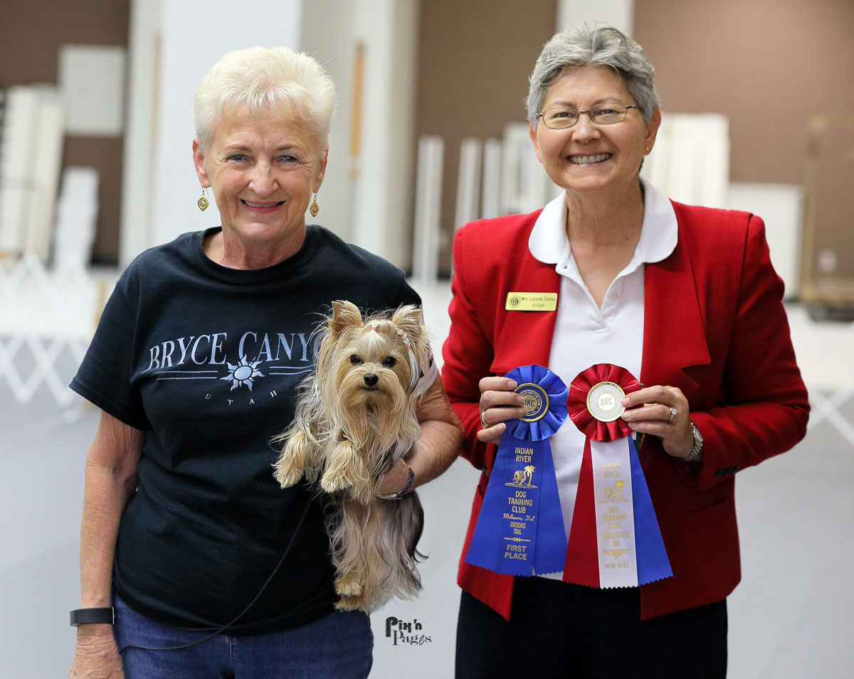

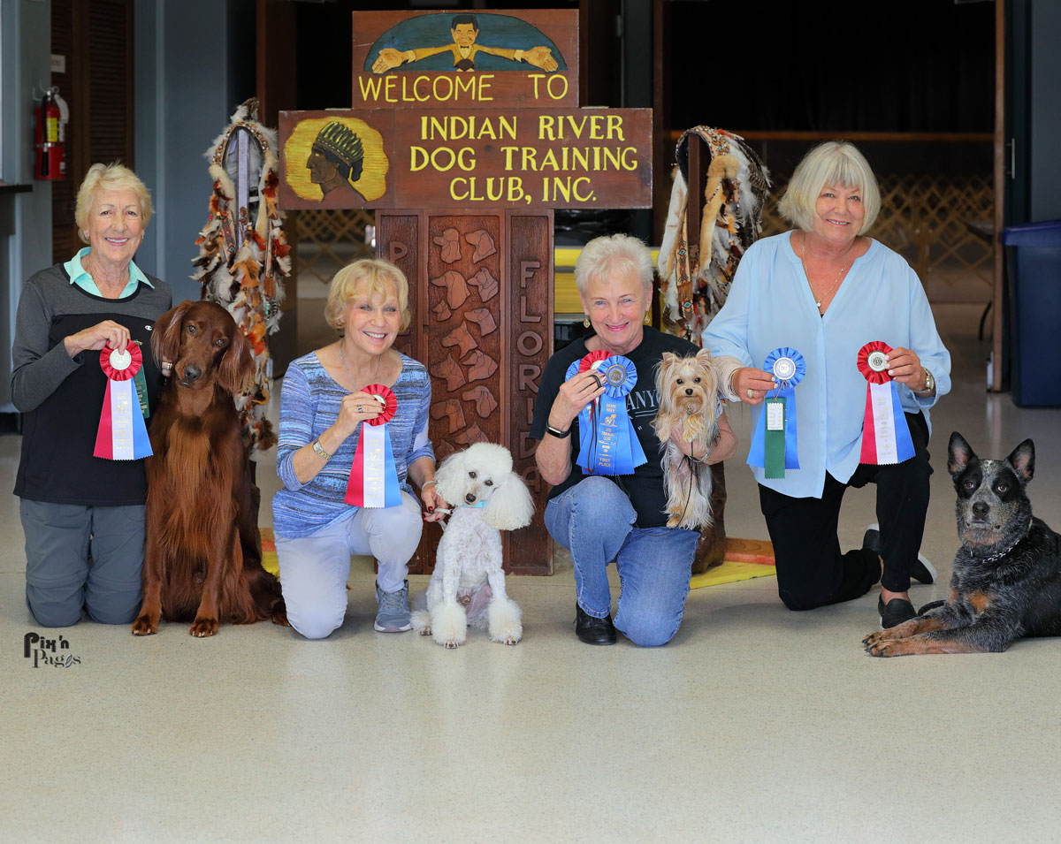

Fate representing our breed at the Indian River Dog Club trial in Melbourne, FL.

Attached are a few pictures of Fate winning a placement in Rally this past weekend being the fastest dog out of 4 who were tied for 3rd place with a score of 98 on Sunday morning 4/28/19. She earned her 1st Rally Advanced leg on Saturday afternoon 4/27/19 with a score of 96.

She also earned her Rally Advanced title this afternoon with a score of 88 due to a 10 point deduction for a handler error!!!

She's been invited to represent our Obedience Club in the state competition in Rally over Labor Day weekend in Kissimmee, FL.

She's also in the 1st round pick to represent the club in Obedience that same weekend!

She's a wonderful working little dog! She's never taken a Rally class!

Submitted by Betty 4/29/19

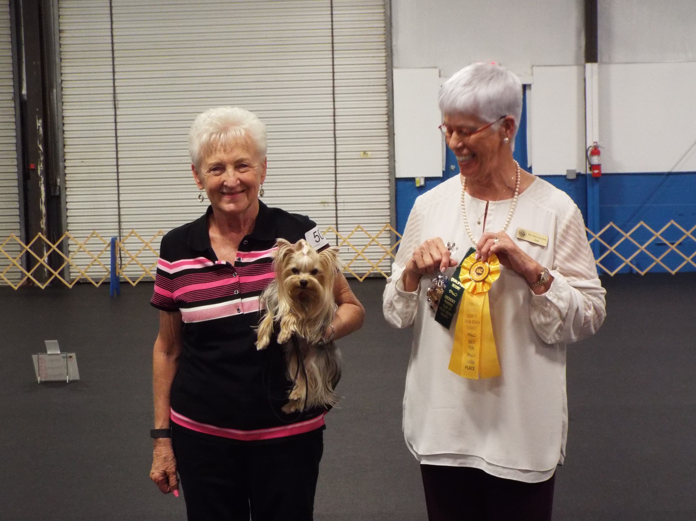

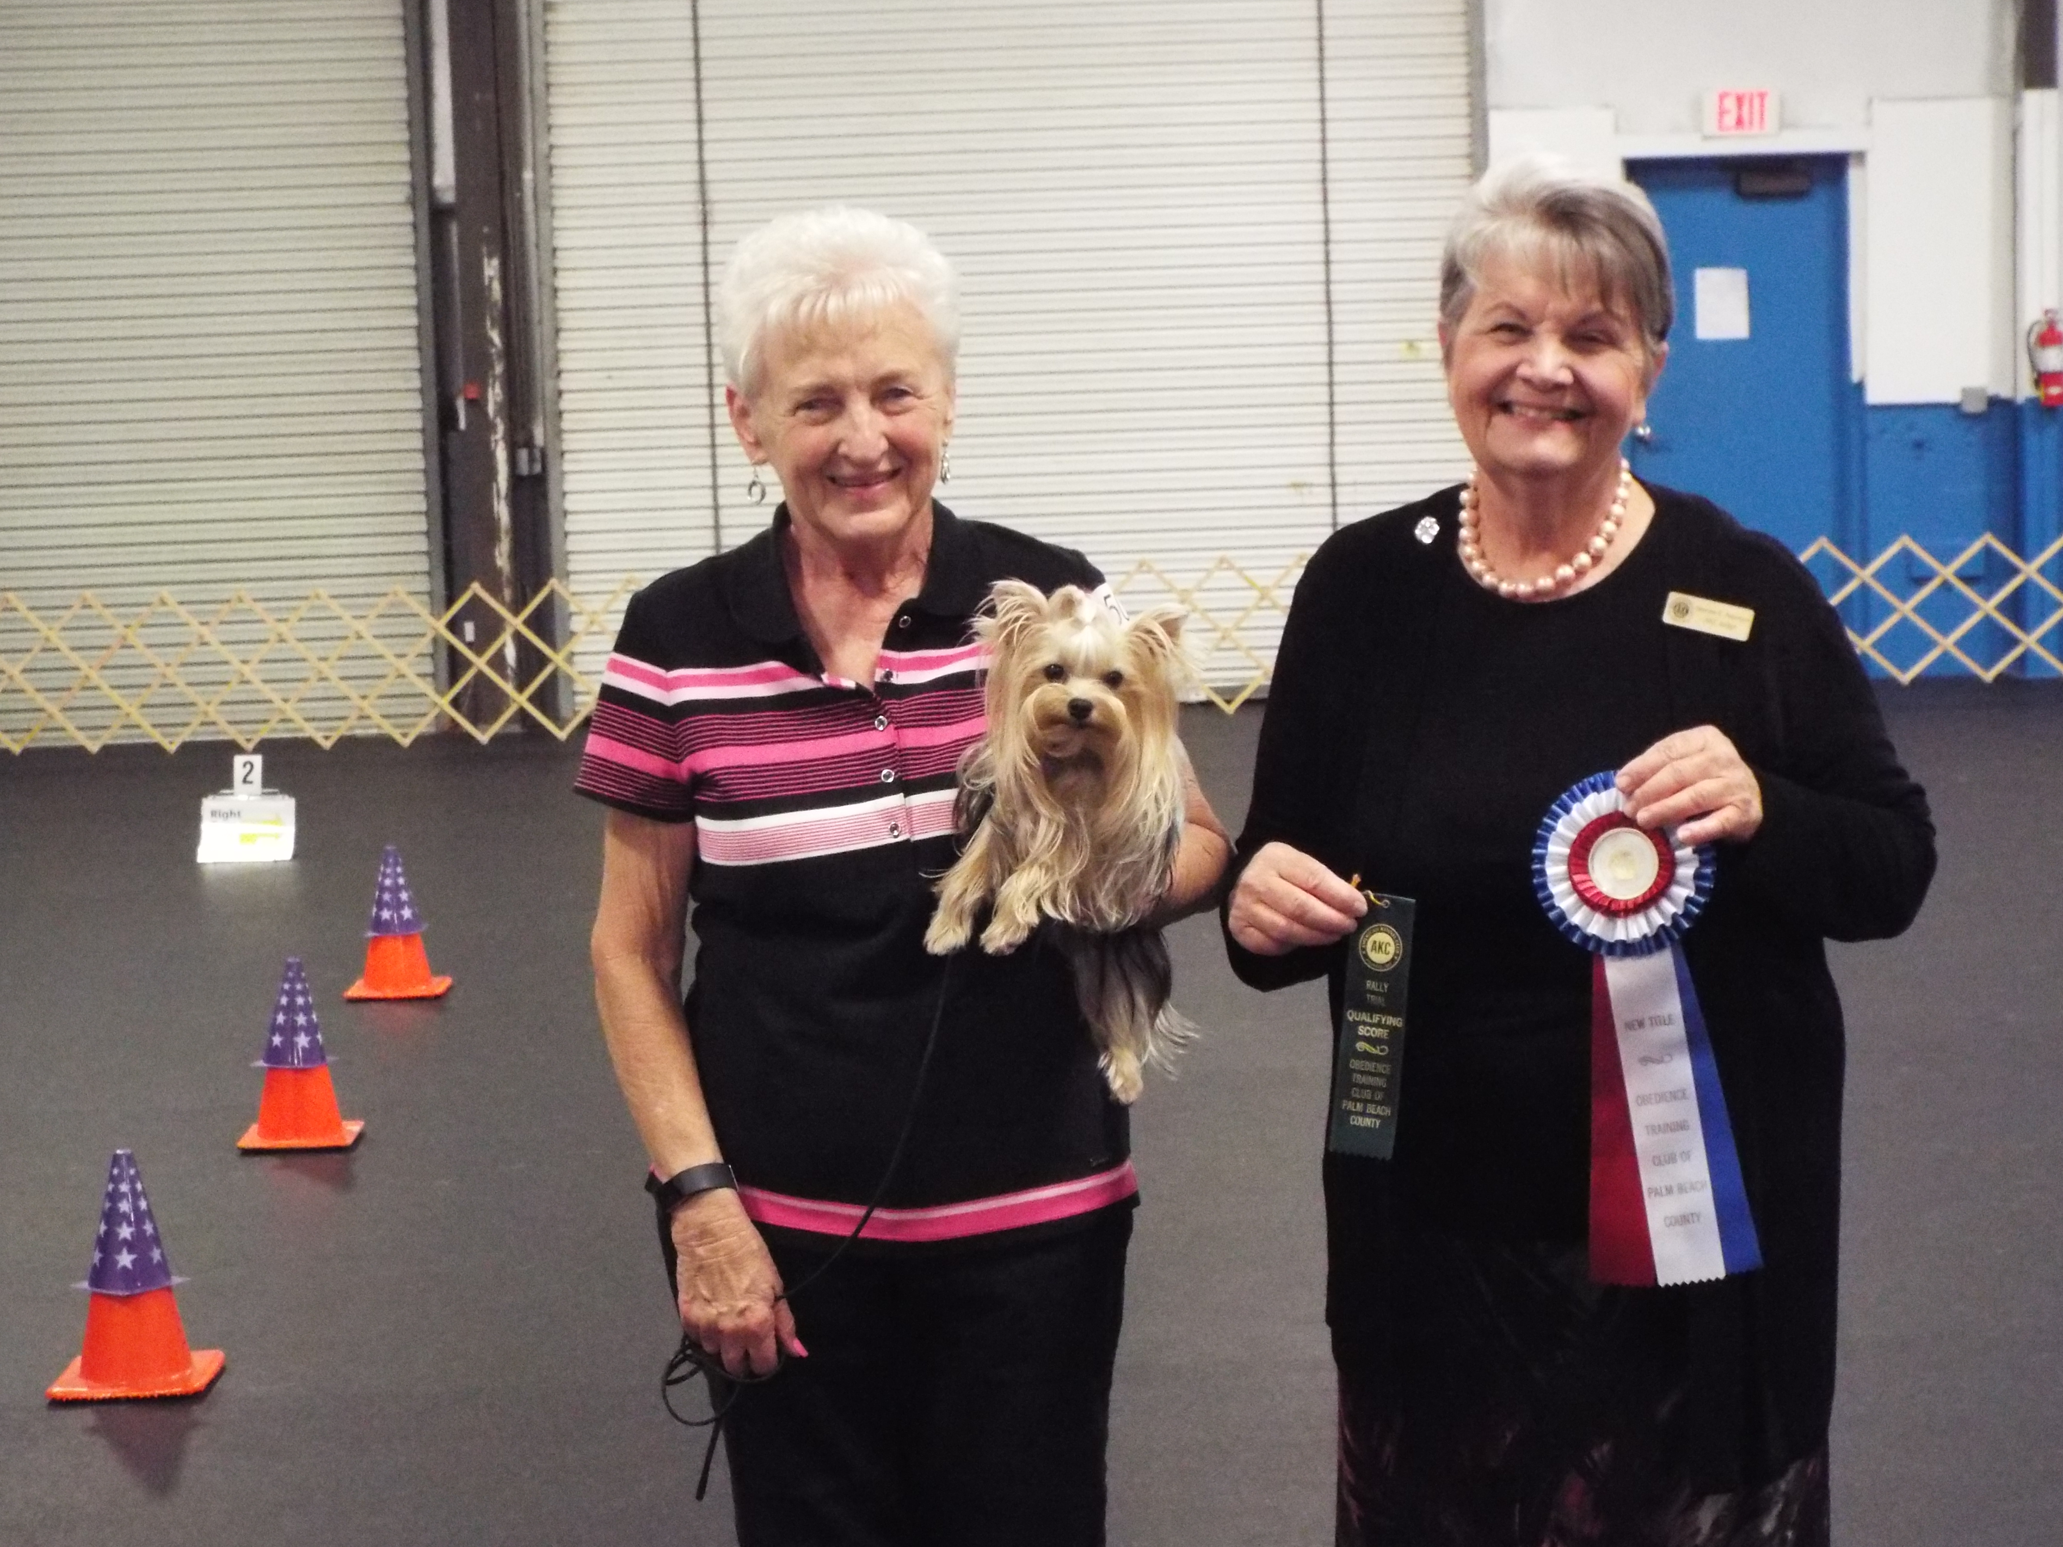

Making us all so proud.

Congratulations Betty & Fate!

