/i
 Y orkie Yapper
Goldcoast Yorkshire Terrier Club
Of South Florida Inc.
Editor; Sherill Freeman, 5750 SW 48th St. Davie, FL. 33314  954-850-2309 cell email: sherillfreeman1@bellsouth.net  Buttons & Angel hopes everyone has a fun and safe July 4th.      Hurricane Survival Kit for Dogs  - Food and water, enough for two weeks.  - Any Medication.  - Collar and Leash.  - Rabies Tag and Identification, photo ID of you and your pet.  - Crate or Carrier.  - Blankets and Towels.  - Newspapers, trash bags, cleaning solution.  - Toys for stress relief.  - Dog first aid kit.  10) Manual can opener, paper towels. | July 2018    


Enjoy!



Special Birthday Wishes to Stephanie Crossley 7/25.

Mark your calendars!

Annual Picnic will be on Saturday at Quiet Waters Park on 10/27. “Pavilion “D” at noon.

Here's your (not so) totally useless fact(s) of the day:

The Dewey Decimal System is the most widely used method for classifying books in the library. It is named after Melvil Dewey, an American librarian who developed it in 1876. The classification's notation makes use of three-digit Arabic numerals for main classes, with fractional decimals allowing expansion for further detail. The number makes it possible to find any book and to return it to its proper place on the library shelves. The classification system is used in 200,000 libraries in at least 135 countries.

Here's your (not so) totally useless fact(s) of the day:

Rudolf Wanderone was a professional pocket billiards player, also known as "Minnesota Fats". He was perhaps the most publicly recognized pool player in the United States — not only as a player, but also as an entertainer Wanderone adopted the nickname "Minnesota Fats" from a character in the 1961 film The Hustler, claiming that the character was based upon him. Fats, who once weighed 245 pounds, could shoot pool with either hand and was known for wearing $100 bills in the handkerchief pocket of his suits.

Brags Litter Basket

Molly had three baby boys on June 5th. She whelped them naturally with the expert help of Carole DellaPenna. Babies are doing very well, gaining weight and contented. Molly is a wonderful mother. I will take pictures as soon as their eyes open.

I think that their names will be Charlie, Andy and Eddie but that keeps changing.

Submitted by Leslie 6/11/18



Show Time!
GYTC Specialty Show 7-14-2018 WPB. Entries closed on 6/27/18. As soon as I know the ring and time I will alert everyone.

If anyone has anything to add to the Yapper please just drop me a email and will gladly add it to the next outgoing issue. Any suggestions/articles are welcome too!
The best way to forget your troubles is to wear tight shoes.

Upcoming Dog Shows: See www.akc.org and/or www.Infodog.com

Check out our website @ www.goldcoastyorkieclub.org

 Take the time to Live!
Life is too short!



Brags

Angel earned her 1st leg in Utility on Saturday June 9th, 2018 at OTC's trial at our clubhouse under Judge Helen Smith.

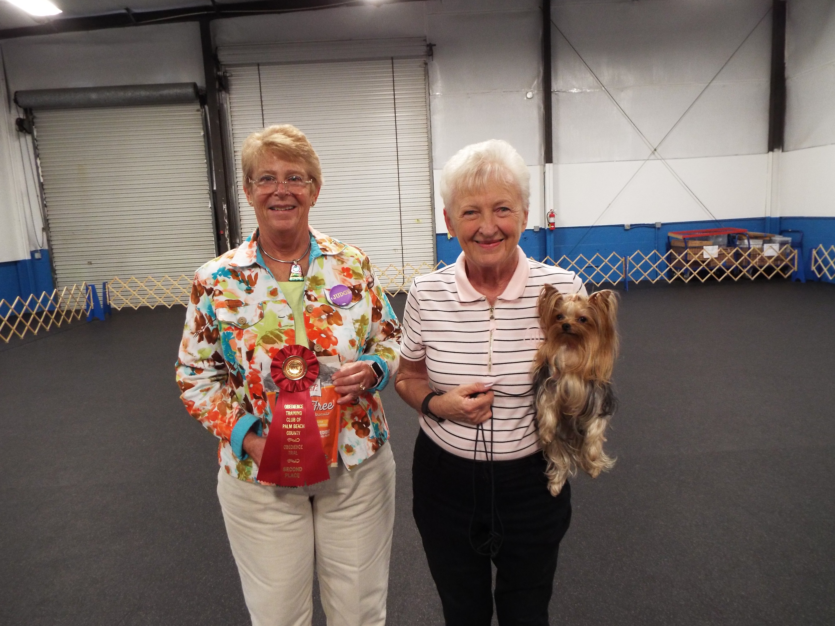

I'm very proud of my "little Angel"!

Submitted by Betty 6/9/2018

Brag

I was totally surprised when I received a certificate from the AKC stating that my little Angel had been awarded the "Achiever Dog" title after receiving titles in 4 different AKC venues. This came the day after her 8th birthday.

The certificate reads, "Winsome's Devil In Disguise, CDX, BN, VER, RAE, MX, AXJ, MXP2, MXPB, MJP, NF, OFP, TKA owned by Betty Gansky is recognized as an Achiever Dog".

I am very proud of this tiny dog who at less than 4 lbs has accomplished so much! She is also one of the sweetest Yorkie's I've ever met as well as my outstanding companion.

Submitted by Betty 6/30/18.



