/i
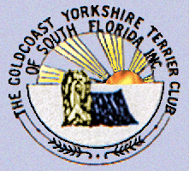 Y orkie Yapper
Goldcoast Yorkshire Terrier Club
Of South Florida Inc.
Editor; Sherill Freeman, 5750 SW 48th St. Davie, FL. 33314  954-850-2309 cell email: sherillfreeman1@bellsouth.net   Happy Father’s Day! | June 2017  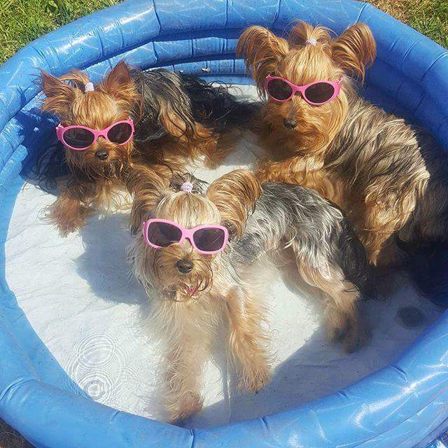

Next Meeting Annual Awards Luncheon: 6/24/17 (Saturday)
@ Sawa Hibachi Steakhouse 1 p.m.

"Sawa Hibachi" restaurant located in the "Shoppes at Woolbright" 10817 Jog Rd, Suite 210, Boynton Beach, FL 33437.The price is $21.00
including full meal, tax, tip & beverage. Please RSVP to Betty Gansky Please mail your check to Pat Cupp 6095 Bay Isles Drive Boynton Beach,
FL 33437 Deadline 6/22 Choice of Chicken, Shrimp, or Steak Hibachi & will include a beverage, soup & salad, white or brown rice, noodles & vegetable. Day of lunch cash only.

Upcoming Dog Shows: See www.akc.org and/or www.Infodog.com

Check out our website @ www.goldcoastyorkieclub.org

Yorkie’s, Make It in the Top 10 Most Popular Breeds 2016 AKC

Friendly reminder: All dues are due 6/1/17


GYTC Specialty Show 7-15-2017
Thanks again to all who donated trophies.
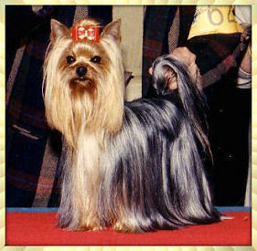



Special Birthday Wishes to Carole Yerkes 6/17

Celery has negative calories! It takes more calories to eat a piece of celery than the celery has in
it to begin with. It's the same with apples!

When you lose, don't lose the lesson.

Avoid biting when a simple growl will do.

Speak only well of people and you need never whisper.

Annual Picnic will be on Saturday at Quiet Waters Park. “Date to be determined.”

GOLDCOAST YORKSHIRE TERRIER CLUB OF SOUTH FLORIDA, INC.

Awards Date June 24, 2017

The Goldcoast Yorkshire Terrier Club of South Florida will be presenting awards at the annual banquet. Yorkshire Terriers that qualified between January 1st and December 31st, 2016 can only be submitted. To qualify for any awards, applications must be received by May 1st, 2017, by mail, email, (sherillfreeman1@bellsouth.net.) Or by fax to Mrs. Sherill Freeman at the address listed below.

------------------------------------------
Reminder Dues

We value you as a member, Membership dues are $20.00 per year for each
single membership, $25.00 per year for a dual membership (husband and wife) payable to: Goldcoast Yorkshire Terrier Club of South Florida. Please continue your membership by sending your dues by June 1, 2017 to:

Ms. Pat Cupp
6095 Bay Isles Drive
Boynton Beach, FL 33437
Name(s) __________________________________________

Address__________________________________________

Type of Membership_______ SINGLE______________DUAL

AMOUNT ENCLOSED $_____________________________

Brags!

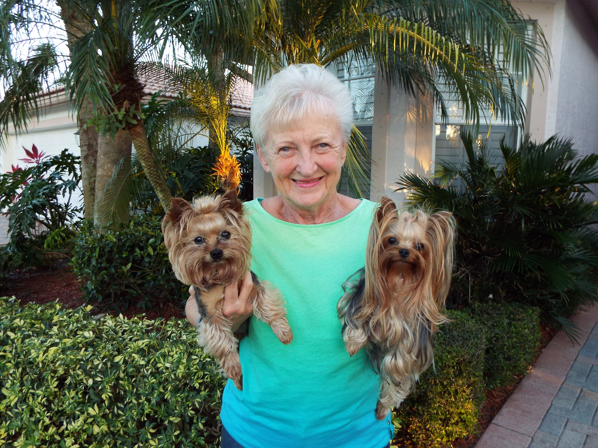

Starting May 1, 2017, the AKC started offering titles in "Tricks". To qualify for a title a dog without a Canine Good Citizen title must do 10 Novice tricks twice. For the Intermediate title, all dogs must do 10 harder tricks twice. For the Advanced title, the dogs must do 5 even harder tricks once.

On Sunday, the Obedience Training Club of PBC offered its 1st tricks titling event. I'm very proud to say that both Angel & Buttons earned all 3 of their titles.

I'm especially proud of Buttons who will be 11 on May 28th. He has been retired for 4 years! Who said that "an old dog can't learn new tricks? Evidently, they didn't know a
dog like Buttons!

Angel was outstanding as well. She did all 45 things outside in the field including Obedience. She has never worked outdoors in anything but Agility.

I'm very proud of both of my "kids"!

Betty & the "Working Yorkies" Angel aka Winsomes Devil In Disguise,CDX,VER, RAE,MX,MXP2,AXJ,MJP,NF,OFP, TKN, TKI, TKA
Buttons aka Nat'l International U-CH Majestics Tailor Made,CDX,RE,OJP,OAP,T-BAD, TG-2,TDIG,THDD, TKN, TKI, TKA

Reminder-Please bring your sold raffle tickets to the next meeting.
All money needs to go to Pat.

Hope to see everyone there!



